MP4: Querying MySQL

### This document is for writing MP4 submissions.

### MP4 is specified in this [instruction document](https://docs.google.com/document/d/1eIMyQWt5ORtxOPJF6fYpZI-LqUoujzEY/edit?usp=sharing&ouid=105332951163580151352&rtpof=true&sd=true).

### All updates, FAQ, and bug fixes, if any, will be announced in [this post](https://campuswire.com/c/G76F915C7/feed/184). Please check it frequently.

### Just write your work on this document, which you will have access to till the deadline. No separate submission is necessary.

### Your work on this document will be graded here by the staff, after the deadline.

# Grading by Staff

| **Submission** | **Weight** | **Comments** | **Grade** |
| --- | --- | --- | --- |
| 1.1 | 5 |  |  |
| 1.2 | 10 |  |  |
| 1.3 | 10 |  |  |
| 2.1 | 20 |  |  |
| 2.2 | 20 |  |  |
| 2.3 | 20 |  |  |
| 2.4 | 20 |  |  |
| 2.5 | 20 |  |  |
| 2.6 | 20 |  |  |
| 2.7 | 20 |  |  |
| 2.8 | 20 |  |  |

# Table of Content

* Submission 1.1
* Submission 1.2
* Submission 1.3
* Submission 2.1
* Submission 2.2
* Submission 2.3
* Submission 2.4
* Submission 2.5
* Submission 2.6
* Submission 2.7
* Submission 2.8

# Instructions:

* Work on the MP.
* Provide your answers in this work document– **one submission on each page** that follows.

# Submission 1.1

## 

# 

# 

# 

# 

# 

# 

# 

# 

# 

# Submission 1.2

Faculty table:

# 

faculty_keyword table:

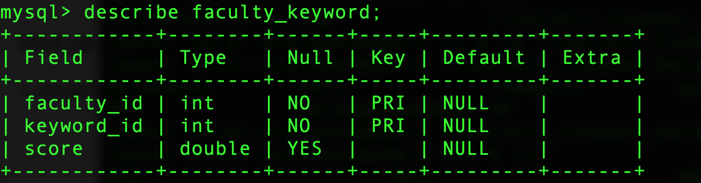

faculty_publication table

# 

keyword table

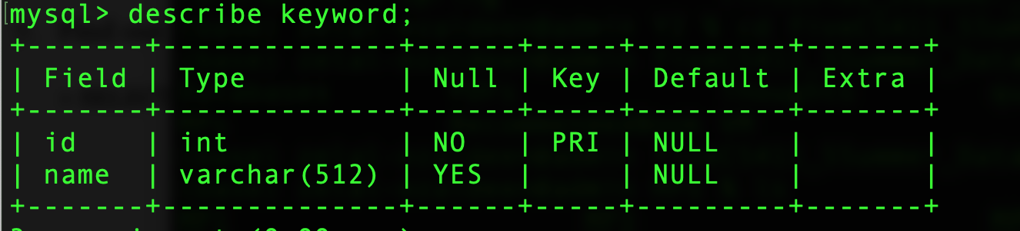

publication table

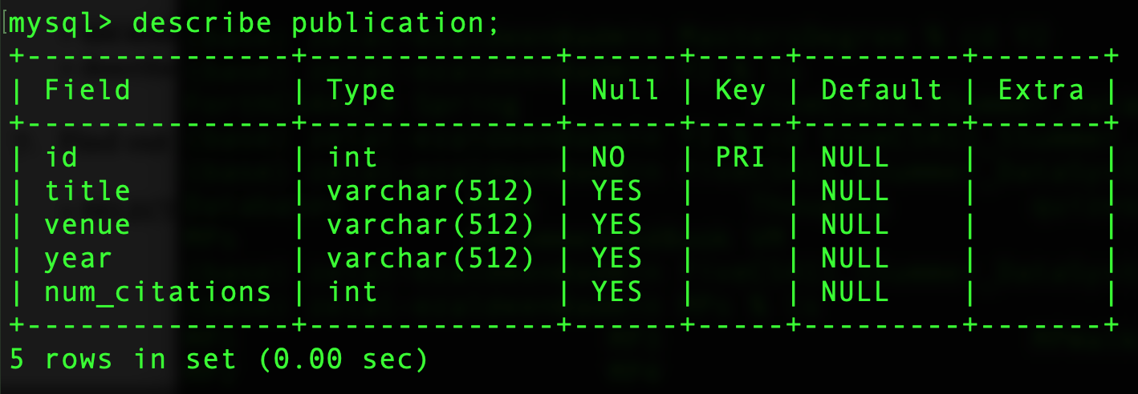

publication_keyword table

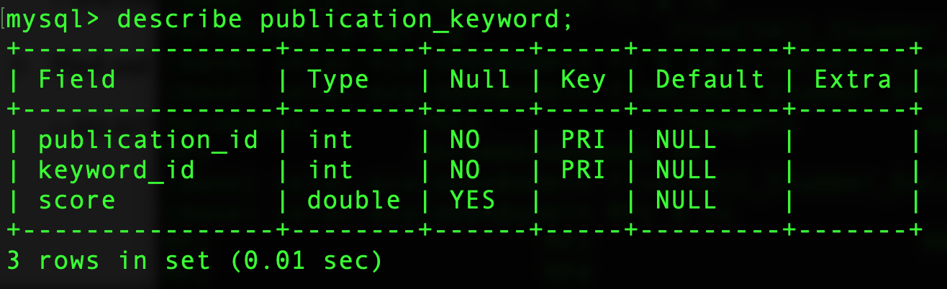

university table:

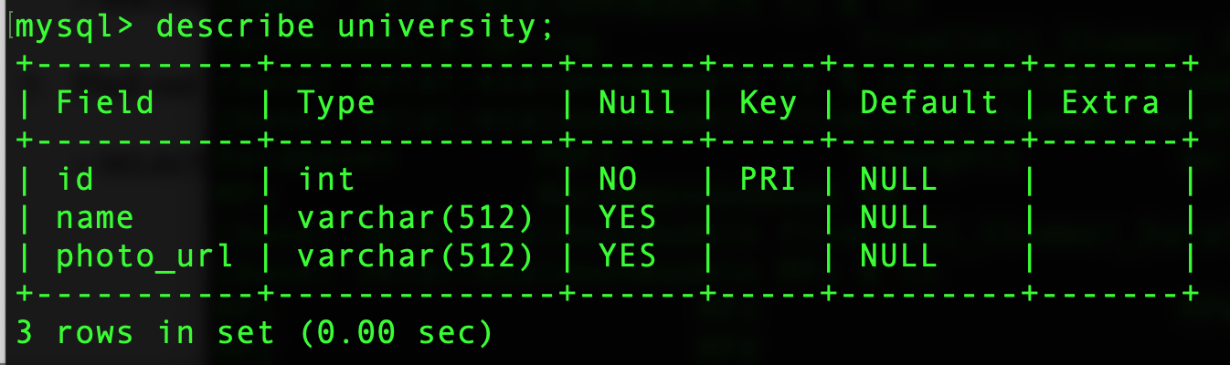

# 

# 

# Submission 1.3

# 

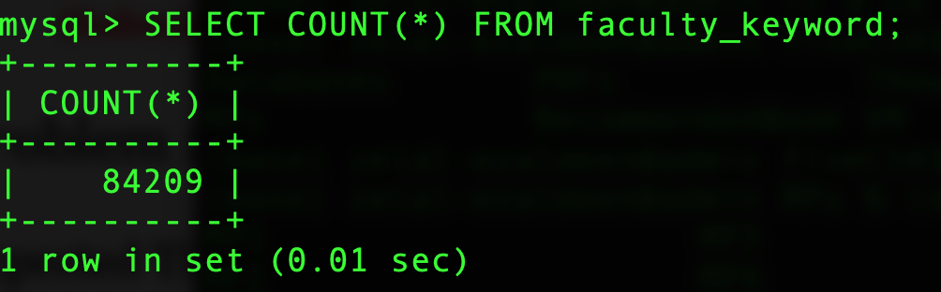

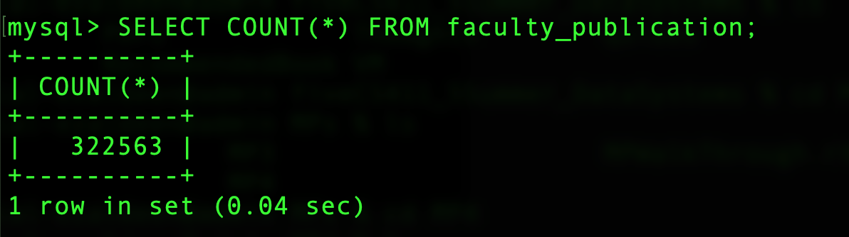

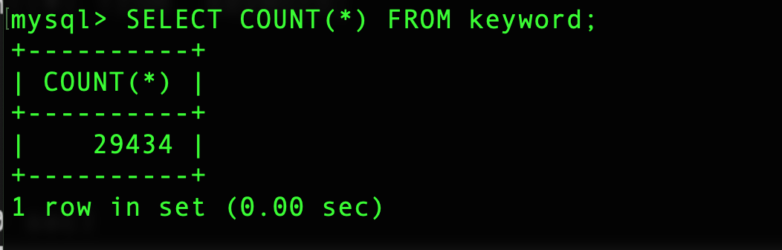

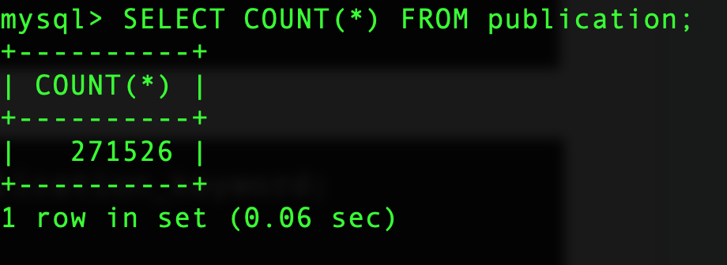

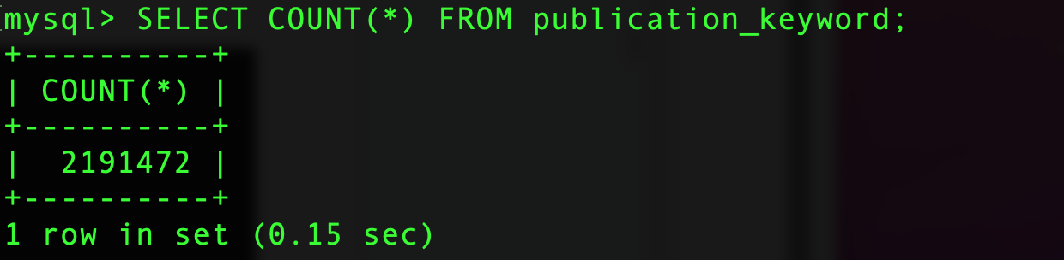

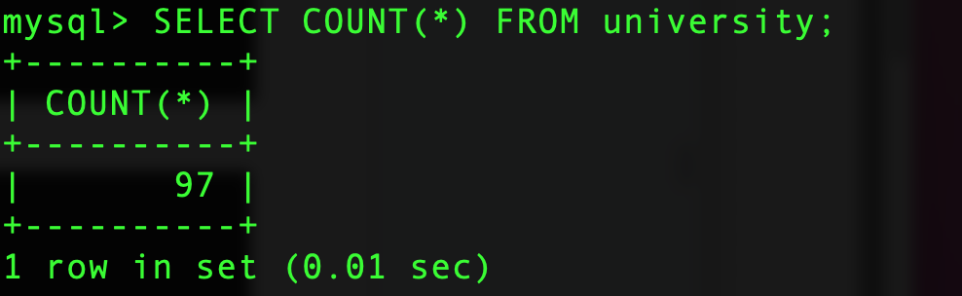

# Submission 2.1

Query: SELECT COUNT(*) FROM faculty WHERE position = "Assistant Professor";

# 

# Submission 2.2

# Query: SELECT F.name from faculty F, keyword K, faculty_keyword FK, university U where K.name="computer vision" AND FK.score>=50 AND K.id=FK.keyword_id AND U.name = "University of Illinois at Urbana Champaign" AND U.id=F.university_id AND

# F.id=FK.faculty_id;

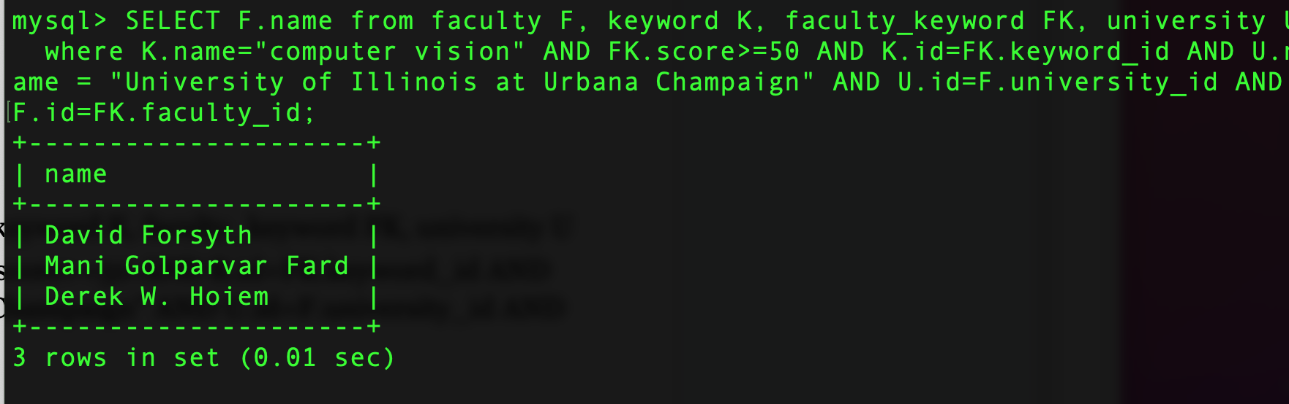

# 

# Submission 2.3

SELECT name, COUNT(publication.id) from keyword K,publication_keyword PK,

publication WHERE publication.id=PK.publication_id AND publication.year >= 2012

AND K.id=PK.keyword_id GROUP BY name ORDER BY COUNT(publication.id) DESC LIMIT

10;

## 

## 

# Submission 2.4

# Query: SELECT (F.name) AS name FROM faculty F, publication P, faculty_publication FP WHERE F.id=FP.faculty_id AND P.id=FP.publication_id AND P.year=2012 AND P.num_citations>10 GROUP BY F.name HAVING COUNT(FP.publication_id)>10 ORDER BY TRIM(F.name) ASC;

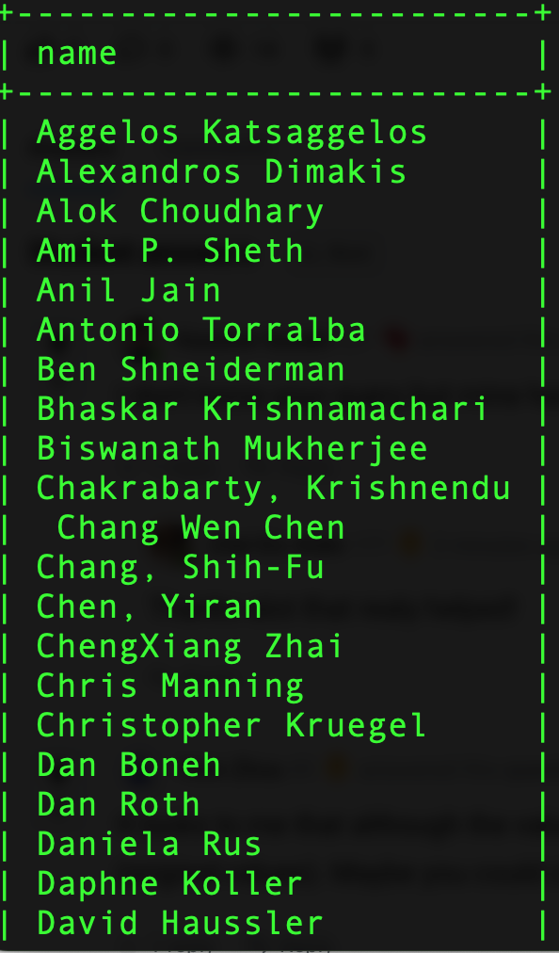

# 

# Submission 2.5

# Query: SELECT U.name, COUNT(DISTINCT F.id) AS counts FROM university U,faculty F, keyword K, faculty_keyword FK WHERE F.id=FK.faculty_id AND K.id=FK.keyword_id

# AND U.id=F.university_id AND K.name LIKE '%data%' GROUP BY U.name ORDER BY counts DESC LIMIT 1;

# 

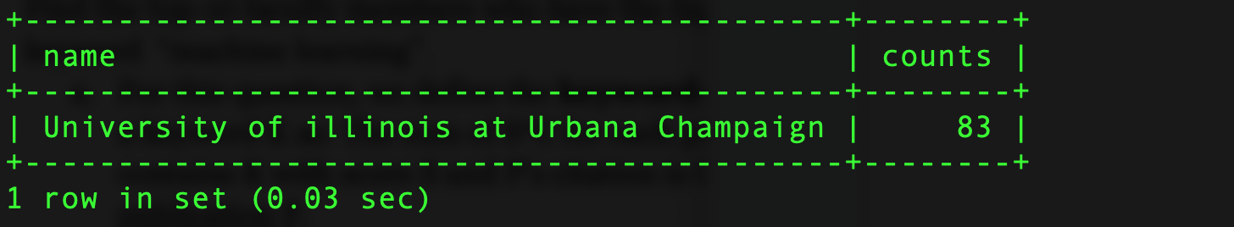

# 

# Submission 2.6

Query: SELECT F.name, SUM(PK.score*P.num_citations) AS KRC FROM faculty F,publication_keyword PK, publication P, faculty_publication FP, keyword K WHERE F.id=FP.faculty_id AND P.id=PK.publication_id AND K.id=PK.keyword_id AND FP.publication_id=P.id AND K.name="machine learning" GROUP BY F.name ORDER BY KRC DESC LIMIT 10;

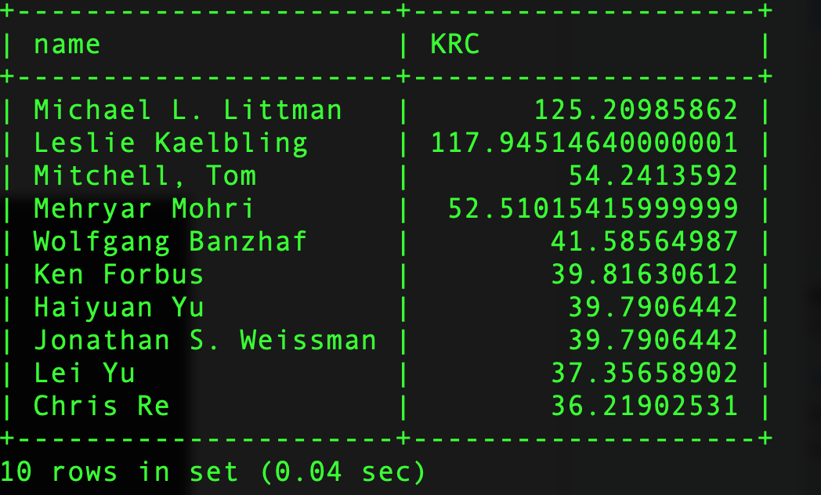

# 

# 

# 

# Submission 2.7

# Query: SELECT P.title FROM publication P, faculty_publication FP,publication_keyword PK, keyword K WHERE K.name="machine learning" AND FP.publication_id=PK.publication_id AND P.id=PK.publication_id AND K.id=PK.keyword_id AND P.year<2016 GROUP BY P.title HAVING COUNT(DISTINCT FP.faculty_id) ORDER BY COUNT(DISTINCT FP.faculty_id) DESC, P.title ASC LIMIT 10;

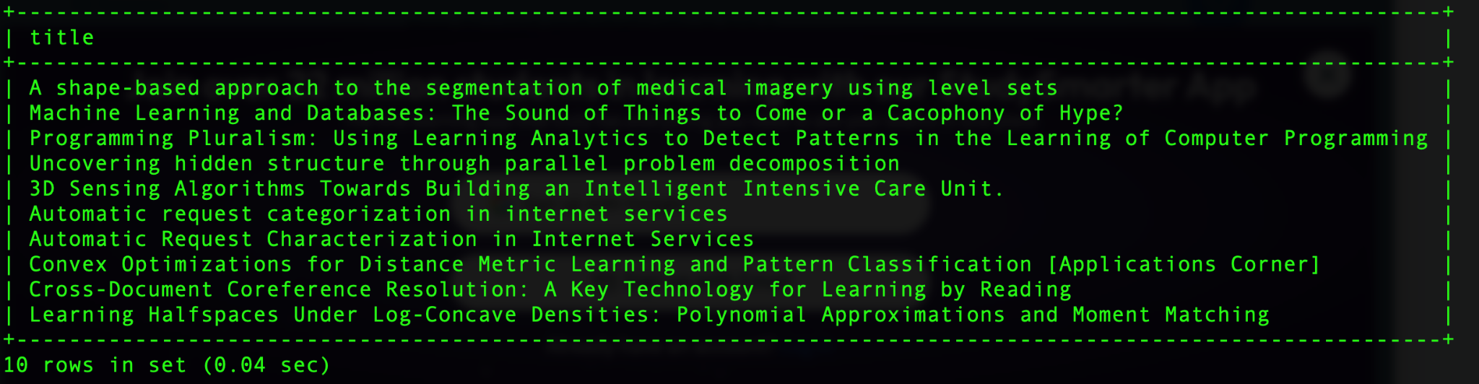

# 

# Submission 2.8

Query: SELECT U.name FROM university U,faculty F, keyword K, faculty_keyword FK WHERE F.id=FK.faculty_id AND K.id=FK.keyword_id AND U.id=F.university_id AND K.name **IN("machine learning","computer vision","natural language processing", "data mining","information retrieval")** AND U.name IN ("University of Illinois at Urbana Champaign","University of California--Berkeley","Stanford University") GROUP BY U.name ORDER BY COUNT(DISTINCT F.id) DESC LIMIT 1;

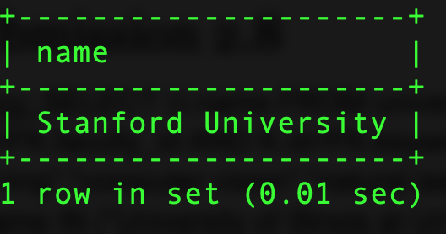

**Fig1(to be removed after the explanation)**

